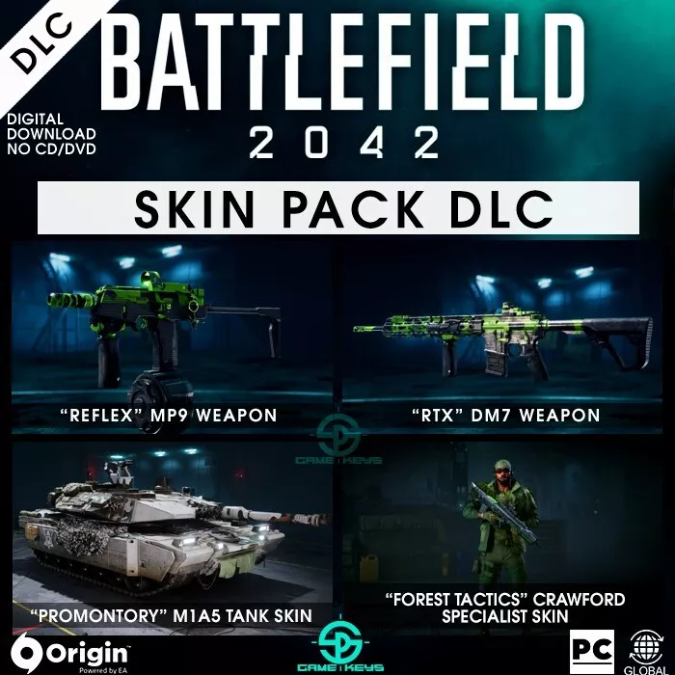

*Battlefield 2042:*

1️. **Massive 128-Player Battles** *(on PS5, Xbox Series X/S, and PC)*

* The largest **Battlefield maps ever**, with **real-time destruction and chaos**. *(Limited to 64 players on PS4 & Xbox One)*

2️. **Specialist System Instead of Traditional Classes**

* Play as **unique Specialists**, each with their own **gadgets, abilities, and customizable loadouts**.

3️. **Dynamic Weather & Destruction**

* **Tornadoes, sandstorms, and collapsing buildings** make every battle unpredictable.

4️. **Battlefield Portal Mode** *(Classic Battlefield Content Returns)*

* Create and play custom matches with **maps, weapons, and vehicles from older Battlefield games** like **BF3, BF1942, and Bad Company 2**.

5️. **Live-Service & Seasonal Updates**

* New maps, weapons, and Specialists **added through seasonal updates and patches**.